13.62: a) The normal force on the cowboy must always be upward if he is not holding on. He leaves the saddle when the normal force goes to zero (that is, when he is no longer in contact with the saddle, and the contact force vanishes). At this point the cowboy is in free fall, and so his acceleration is ; this must have been the acceleration just before he left contact with the saddle, and so this is also the saddle’s acceleration.
b) c) The cowboy’s speed will be the saddle’s speed, 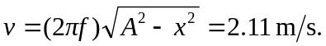 d) Taking  at the time when the cowboy leaves, the position of the saddle as a function of time is given by Eq. (13.13), with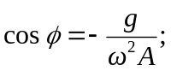 this is checked by setting 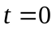 and finding that 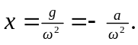 The cowboy’s position is 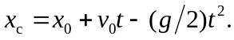 Finding the time at which the cowboy and the saddle are again in contact involves a transcendental equation which must be solved numerically; specifically,

which has as its least non-zero solution 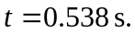 e) The speed of the saddle is and the cowboy’s speed is (2.11 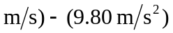
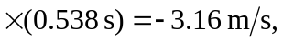 giving a relative speed of 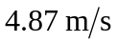 (extra figures were kept in the intermediate calculations).

